Fast**National University of Computer & Emerging Sciences, Karachi**

**EL-213: Computer Organization & Assembly Language Lab**

|  |  |
| --- | --- |
| **Lab 3:** *Registers, Operators & Instructions* | **Session:** Fall 2018 |
| **Instructor(s):** Syed-Zain-ul-Hassan & Hafiz Abdul Khaliq | |

**Introduction to Registers**

To speed up the processor operations, the processor includes some internal memory storage locations, called Registers. The registers store data elements for processing without having to access the memory.

There are ten 32-bit and six 16-bit processor registers in IA-32 architecture. The registers are grouped into three categories:

• General-Purpose registers,

• Control registers, and

• Segment registers

Furthermore, the general registers are further divided into the following groups:

• Data registers,

• Pointer registers &

• Index registers

**Data Registers**

***EAX (Accumulator register)***

It is used in input/output and most arithmetic instructions. For example, in multiplication operation, one operand is stored in EAX or AX or AL register according to the size of the operand.

***EBX (Base register)***

It could be used in indexed addressing.

***ECX (Counter register)***

The ECX, CX registers store the loop count in iterative operations.

***EDX (Data register)***

It is also used in input/output operations. It is also used with AX register along with DX for multiply and division operations involving large values.

These four 32-bit registers are used for arithmetic, logical, and other operations.

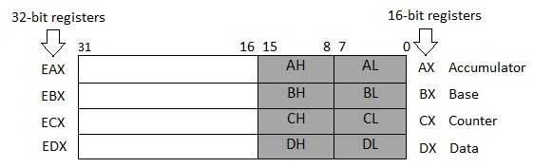

**Pointer Registers**

The pointer registers are 32-bit EIP, ESP, and EBP registers and their corresponding 16-bit portions IP, SP, and BP.

***Extended Instruction Pointer (EIP)***

The EIP register stores the offset address of the next instruction to be executed.

***Extended Stack Pointer (ESP)***

The ESP register provides the offset value within the program stack.

***Extended Base Pointer (EBP)***

The EBP register mainly helps in referencing the parameter variables passed to a subroutine.

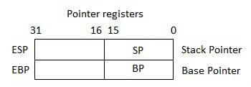

**Index Registers**

The 32-bit index registers, ESI and EDI, and their 16-bit rightmost portions. SI and DI, are used for indexed addressing and sometimes used in addition and subtraction.

***Extended Source Index (ESI)***

It is used as source index for string operations.

***Extended Destination Index (EDI)***

It is used as destination index for string operations.

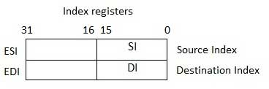

***MOV* Instruction**

It is used to move data from source operand to destination operand

• Both operands must be the same size.

• Both operands cannot be memory operands.

• CS, EIP, and IP cannot be destination operands.

• An immediate value cannot be moved to a segment register.

***Syntax:***

MOV *destination*, *source*

***Example:***

MOV *bx, 2*

MOV *ax, cx*

***Example:***

‘A’ has ASCII code 65D (01000001B, 41H)

The following MOV instructions stores it in register BX:

*MOV bx, 65d*

*MOV bx, 41h*

*MOV bx, 01000001b*

*MOV bx, ‘A’*

All of the above are equivalent.

***Examples:***

The following examples demonstrate compatibility between operands used with MOV instruction:

MOV ax, 2 ✓

MOV 2, ax **✕**  
MOV ax, *var* ✓

MOV *var*, ax ✓

MOV *var1*, *var2* **✕**

MOV 5, *var* **✕**

**INC Instruction**

The INC instruction takes an operand and adds 1 to it.

***Example:***

MOV *ax, 8*

INC *ax* ; *ax now contains 9*

**DEC Instruction**

The DEC instruction takes an operand and subtracts 1 from it.

***Example:***

MOV *ax, 5*

DEC *ax ; ax now contains 4*

**MOVZX Instruction**

The MOVZX (MOV with zero-extend) instruction moves the contents and zero­extends the value to 16 or 32 bits. This instruction is only used with unsigned integers.

***Syntax:***

MOVZX *reg32,reg/mem8*

MOVZX *reg32,reg/mem16*

MOVZX *reg16,reg/mem8*

***Example:***

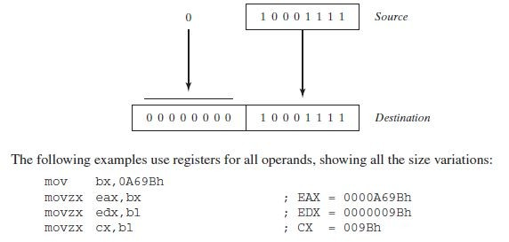

**MOVSX Instruction**

The MOVSX (MOV with sign extend) instruction moves the contents and sign­extends the value to 16 or 32 bits. This instruction is only used with signed integers.

***Example:***

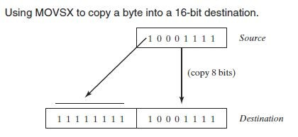

**DUP Operator**

The DUP operator allocates storage for multiple data items, using a constant expression as a counter. It is particularly useful when allocating space for a string or array, and can be used with initialized or uninitialized data.

***Examples:***

*v1* BYTE 20 DUP(0) *; 20 bytes, all equal to zero*

*v2* BYTE 20 DUP(?) *; 20 bytes, uninitialized*

*v3* BYTE 4 DUP("STACK"),0 *;20 bytes, "STACKSTACKSTACKSTACK"*

**FLAGS Register**

Status flags are updated to indicate certain properties of the result. Once a flag is set, it remains in that state until another instruction that affects the flags is executed.

Not all instructions affect all status flags:

• ADD and SUB affect all six flags

• INC and DEC affect all but the carry flag

• MOV, PUSH, and POP do not affect any flags

***Z­ Zero Flag:***

This flag is set, if the result of the computation or comparison performed by the previous instruction is zero.

***C­ Carry Flag:***

This flag is set, when there is a carry out of MSB in case of addition and borrow in case of subtraction. Ranges of 8, 16, and 32 bit unsigned numbers are:

• 8 bits 0 to 255 (28 ­ 1)

• 16 bits 0 to 65,535 (216 ­ 1)

• 32 bits 0 to 4,294,967,295 (232­1)

***S­Sign Flag:***

This flag indicates the sign of the result of an operation. A 0 for positive number and 1 for a negative number.

***AC­Auxilary Carry Flag:***

This flag is set, if there is a carry from the lowest nibble, i.e., bit three during addition, or borrow for the lowest nibble, i.e. bit three, during subtraction.

***P­ Parity Flag:***

This flag is set to 1, if the lower byte of the result contains even number of 1’s

***O­ Over flow Flag:***

This flag is set, if an overflow occurs, i.e., if the result of a signed operation is too large to fit into a destination register. Range of 8­, 16­, and 32­bit signed numbers:

• 8 bits (­ 128 to +127)

• 16 bits (­ 32,768 to +32,767 215)

• 32 bits (­2,147,483,648 to +2,147,483,647 231)

**Exercises:**

**1.** Convert the following high-level instruction into Assembly Language:

x = (x+1) – (y­1) + y

**2.** Write a program in assembly language that implements following expression:

eax = ­val2 + 7 – val3 +val1

Use these data definitions:

val1 word 8

val2 word 15

val3 word 20

**3.** Write a program to find area of a square. Declare necessary variable side for the program (assign any arbitrary value to the variable).

**4.** Write a program to find area of a rectangle. Declare necessary variables length & width for the program (assign arbitrary values to the variables).

**5.** Write a program to find area of a triangle. Declare all necessary variables for the program (give arbitrary values to the variables).

**6.** Use this code for the following questions:

*.data*

*val1 BYTE 10h val2 WORD 8000h*

*val3 DWORD 0FFFFh*

*val4 WORD 7FFFh*

i. Write an instruction that increments val2.

ii. Write an instruction that subtracts val3 from EAX.

iii. Write instructions that subtract val4 from val2.

iv. If val2 is incremented by 1 using the ADD instruction, note down the values of Carry and Sign flags?

v. If val4 is incremented by 1 using the ADD instruction, note down the values of Overflow and Sign flag.